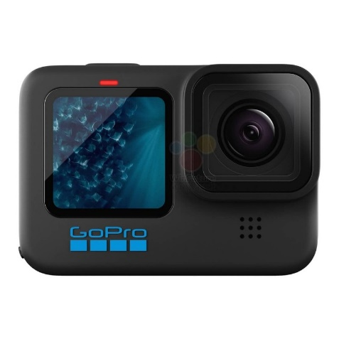
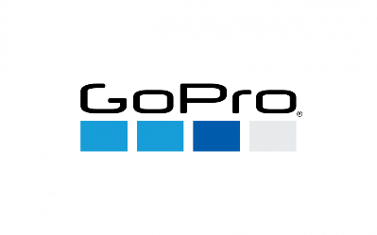


GoPro Hero 11 Black

₨.125,000

Description:

GoPro Hero 11 Black Price & Specs

Take your action videos to the next level with the Hero 11 Black by GoPro. The new, larger image sensor inside the camera will execute amazing scenes in a higher image quality, which will let you share them quickly on your social media. The HyperSmooth 5.0 technology has AutoBoost with Horizon Lock built-in, which will make you shoot some smooth and stunning shots. The latest Night Effects puts a WOW factor on your shots even if they were shot in the dark as well as the 10-Bit color feature brings the true colors of your videos to life. With all these incredible features, the Hero 11 Black makes it to be the best and most powerful GoPro to date. Fortunately, you can buy GoPro Hero 11 in Pakistan from us at the most affordable rates.

What's New In GoPro Hero 11?

Notable Features:

● Automatically uploads footage to the cloud

● Highlights of videos when charging

● New larger image sensor

● Cinematic 5.3K60 + 2.7K240 video with 24.7-megapixels stills

● 27-megapixels high-res photographs

● HyperView of 8:7 aspect ratio footage

● Up to 8x Slo-Mo

● Emmy Award-winning HyperSmooth 5.0 video stabilization with a Horizon look.

● Tough and sturdy build with waterproofing up to 33ft

● Water-repelling lens cover

● Dual LCD Screens

● Star Trails, Light Painting, & Vehicle Light Trails

● Scheduled Capture

What's In The Box:

● HERO11 Black Camera x 1

● Rechargeable Enduro Battery x 1

● Curved Adhesive Mount x 1

● Mounting Buckle x 1

● USB-C Cable x 1

● Thumb Screw x 1

● Camera Case x 1

With all these fantastic features and specifications, the GoPro Hero 11 price is between 140,000 to 145,000 in Pakistan. Isn't it amazing? So, what are you waiting for? Get back to action with this impressive addition by GoPro!

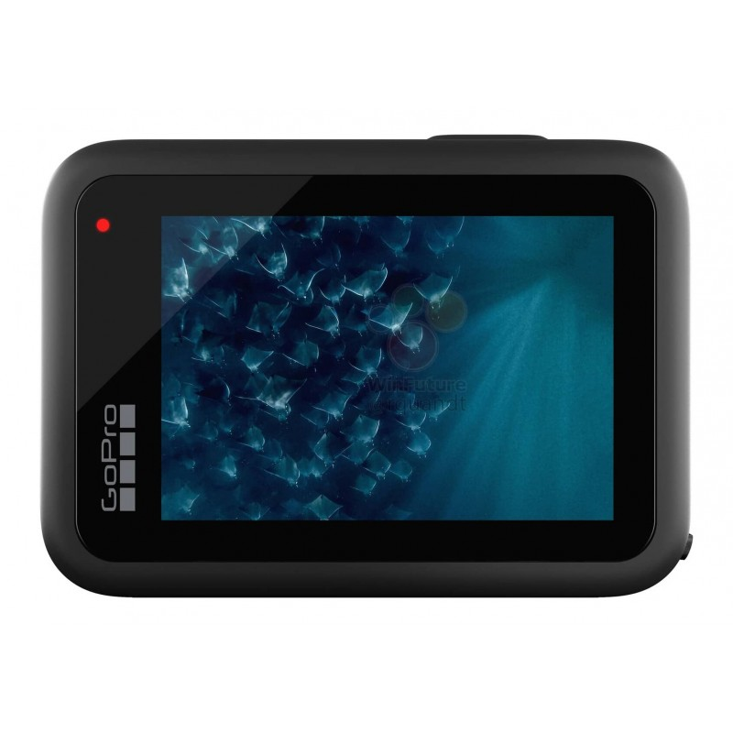
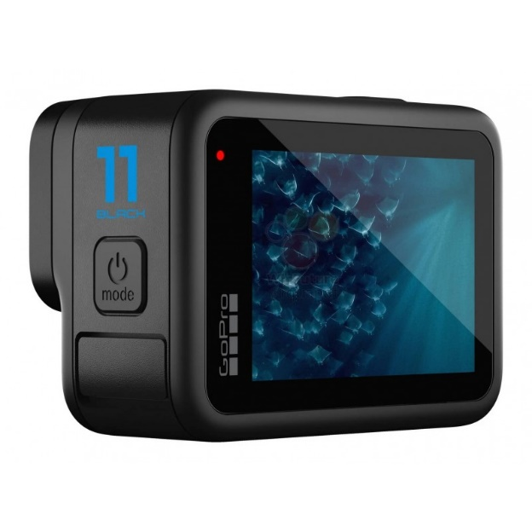
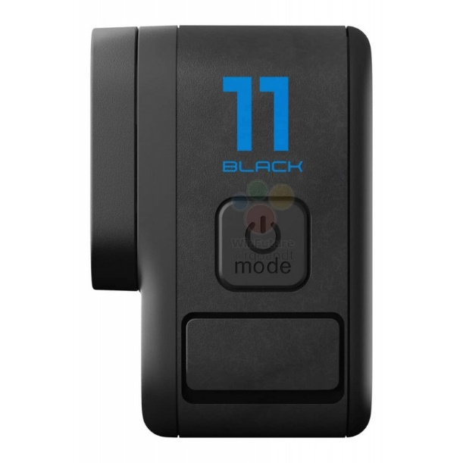
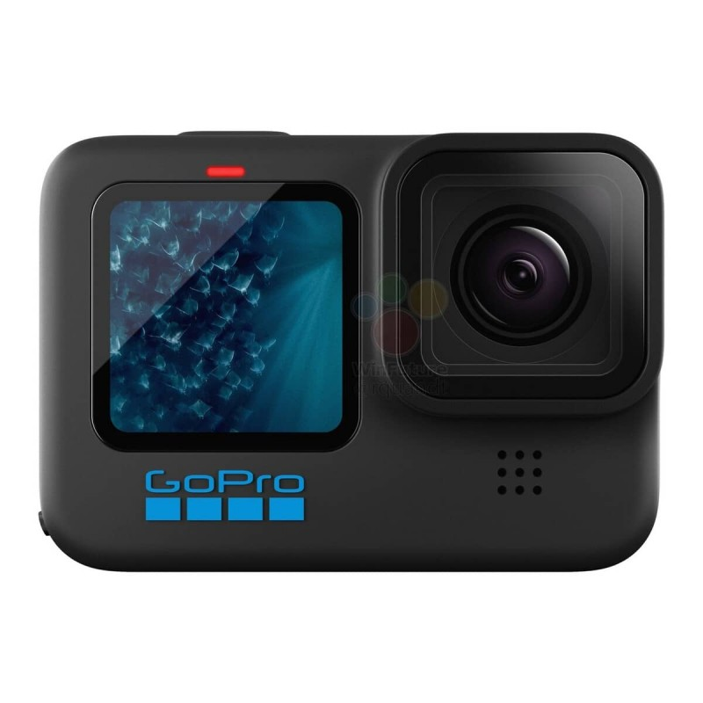
Pictures:

